Paulina Shaw – Cocoon website content – ENG

Website headline ( as you can see on the Google search): Cocoon Warsaw – Coliving for Remote Professionals

Landing Page / Home  
Buttons under the menu button: Home, Cocoons, About us, Invest with us, Contact us



Just under the main banner with Cocoon logo on the top left hand side: RESERVE ME

On the top right-hand side: 

For the Icons use the same spacing in between: Mail Symbol, PL | EN, Facebook, Instagram, LinkedIn (with link to my LinkedIN website to link to my bio

*Large Cocoon logo in a middle*

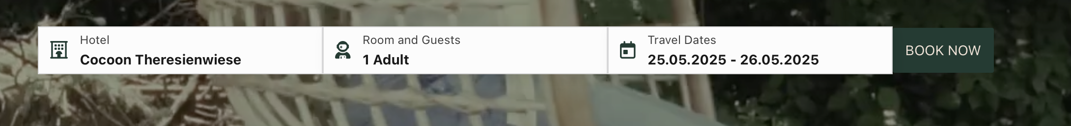

Just instead of Book now: RESERVE ME

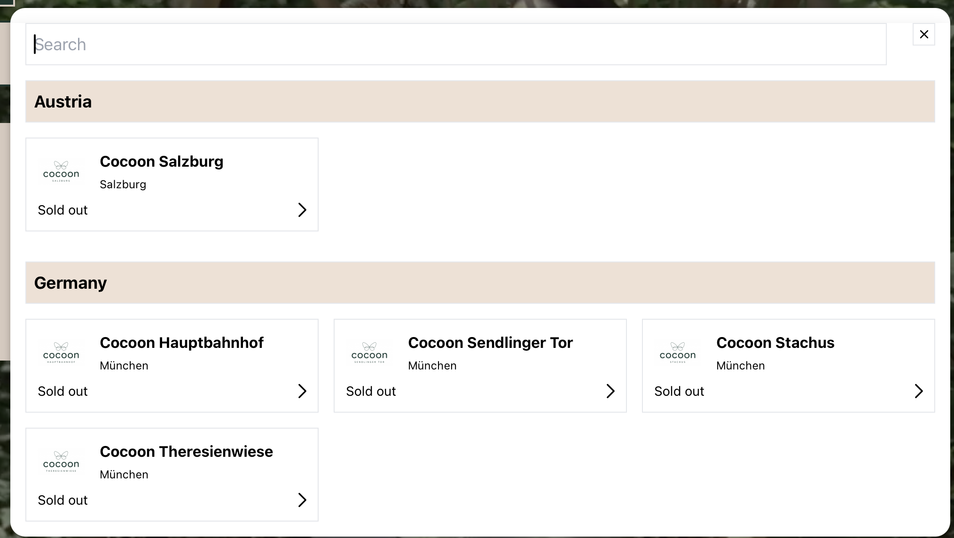

Instead of Hotel - Property:

|  |  |
| --- | --- |
| Cocoon Place Coliving | |
| Cocoon Coliving Warszaw |  |
| Cocoon City | |
| Cocoon City Warszaw - Poland | Cocoon City Porto - Portugal |
| Cocoon City Edinburgh - Scotland – UK | Cocoon City Dubai – United Arab Emirates |

Instead of Room and Guests – Room and Cocooners

Rooms: Room 1 (from 1 - 6)  
Cocooners: (select from +- 1 - 2)  
Buttons: Add room, Save

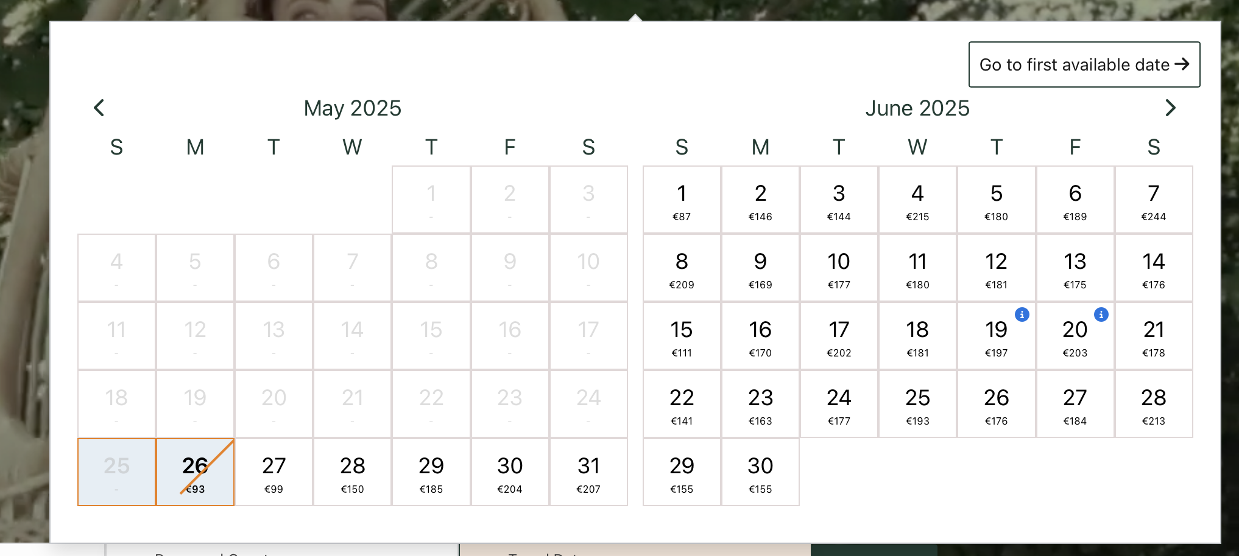

Instead of Travel dates – Next Start Date  
Calendar only for the next available date. The past dates go to super light grey, the available start dates, black.

On the top the button instead of: Go to next available date – Next

*(on our pink background without any frames)*

COCOON: COLIVING HOMES

IN WARSAW

DISCOVER YOUR COLIVING PLACE

WHERE CONNECTION, AND WORK-LIFE BALANCE COME NATURALLY

Since 2003, we’ve been turning spaces into shared homes for remote workers, creatives, and young professionals on the move. Private rooms. Shared energy. Flexible leases. Ultra-fast Wi-Fi. Whether you’re Zooming at 9 or brainstorming at midnight — Cocoon is your base, your vibe, your community.

*(here please overlay the second picture over first so that all this informaiton is on the front page)*

|  |  |  |
| --- | --- | --- |
| **WHAT IS IN?** | | |
| **ESSENTIALS** | **COMFORT** | **PAMPER ME (loading)** |
| Fully furnished houses | Fully equipped kitchen | Airport transportation |
| High-speed Wi-Fi | Web booking | Cheaufeur |
| Workspaces in each room | Bills included | Cook |
| Mid to long term rentals | Swift asisstance | Spa discounts |
|  |  |  |
|  |  |  |

**Rooms at Cocoon Place Warsaw**

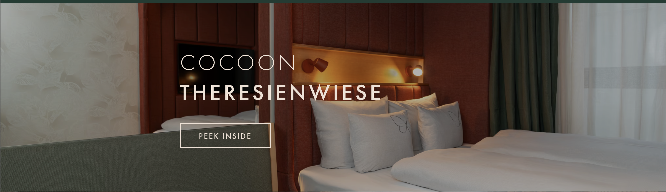(picitre of the room in the background)

|  |  |
| --- | --- |
| COCOON PLACE | Fully furnished | Sofa bed | Laundry room |
| Deluxe singles hideout | Desk and chair | Wardrove with mirror |
| Starting from 1,700 PLN per month | Flexible annual lease |
| Size 9sqm | Penalty-free 30 day notice |
|  | Fixed monthly online payments |
|  | All utilities included |
|  | No broker fees | No bills hassle |

Butoton: RESERVE ME

(picitre of the room in the background)

|  |  |
| --- | --- |
| COCOON PLACE | Fully furnished | Lux Sofa bed | Laundry |
| Premier Solo Escape | Desk and chair | Wardrove with mirror |
| Starting from 1,900 PLN per month | Flexible annual lease |
| Size 10sqm | Penalty-free 30 day notice |
|  | Fixed monthly online payments |
|  | All utilities included |
|  | No broker fees | No bills hassle |

Butoton: RESERVE ME

(picitre of the room in the background)

|  |  |
| --- | --- |
| COCOON PLACE | Fully furnished | Luxurious Double Bed |
| Junior Duo Den | Laundry Room | Nightstand with lamp |
| Starting from 2,100 PLN per month | Desk and chair | Wardrove with mirror |
| Size 12sqm | Chest of drawers | Flexible annual lease |
|  | Penalty-free 30 day notice |
|  | Fixed monthly online payments |
|  | All utilities included |
|  | No broker fees | No bills hassle |

Butoton: RESERVE ME

(picitre of the room in the background)

|  |  |
| --- | --- |
| COCOON PLACE | Fully furnished | Luxurious Double Bed |
| Executive Duo Retreat | Private balcony |
| Starting from 2,300 PLN per month | Laundry Room | 2 x nightstand with lamp |
| Size 15sqm | Desk and chair | Wardrove with mirror |
|  | Chest of drawers | Flexible annual lease |
|  | Penalty-free 30 day notice |
|  | Fixed monthly online payments |
|  | All utilities included |
|  | No broker fees | No bills hassle |

Butoton: RESERVE ME

(picitre of the room in the background)

Page one – Cocoons

**Properties**

We offer a diverse range of property types, from residences to boutique retreats.

**Welcome to Cocoon Place by Cocoon**

where the city hums not just outside, but also inside, everything is designed to make you breathe. Harmony-driven structure, enough comfort, and peaceful green — all wrapped up in one elegant Cocoon. A place where the rhythm of work and play is the same, and the only thing you need to focus on is feeling at home.

Poland – Pruszkow

**Welcome to Cocoon City by Cocoon**

where your stay is as reliable as your favorite coffee and as friendly as a local beer garden. We're all about keeping it practical but with a twist—so you can kick back, stay productive, and soak in all the city perks. Located in the heart of the action, we make sure you're connected, comfy, and ready to roll.

Poland – Warsaw

Portugal– Porto

United Kingdom – Scotland – Edinburgh

United Arab Emirates - Dubai

Page two: About us

**Cocoon Who we are**

Cocoon redefines urban living with curated spaces that balance privacy, connection, and chillaxing.

Paulina Shaw

Founder, trainspotter with ginger head flair.

Paulina Shaw’s extensive background in hospitality and finance shaped Cocoon’s vision. Having worked with industry leaders like Accor, Four Seasons, advised Prince Al Waleed, and collaborated with Dubai and Abu Dhabi governments on strategic alliances, she brings a unique, knowledge-driven approach to addressing housing and hospitality needs. As a Financier, Asset Manager, and Hotelier, her passion influences every design and decision.

LINKEDIN LINK

Cocoon is relentlessly focused on creating exceptional living. Rooted in **hospitality, architecture, facility management and finance**, we uncover opportunities at the intersection of **real estate, technology, and design**, delivering spaces that set a new standard for **modern coliving**.

Desitination – discovered.

Page Break

**Our Inspiration** Cocoon is born to sustainably house small communities.

**Our Name** Cocoon represents transformation that inspires progress, slow living, and authenticity.

**Our Identity** Our soft pink, inspired by flamingos, symbolizes life’s fleeting beauty, harmony, and friends for life — reminding us to find grace in life’s dance.

Page Break

Our Purpose: 3 I’s

Inspire

As a Cocooner (logo + er), I trigger ideas.

Inclusive

As a Cocooner (logo + er), I value empowerment.

Innovation

As a Cocooner (logo + er), I embrace transformation.

Page three: Invest with us

* **Gap to Fill:** Low number of short-term housing for subject matter experts.
* **Strong Returns:** Warsaw rental yields at 6-7% (2024).
* **Easy, Cost-effective Living:** One-click, all-in-one services.
* **Built for Connection:** Combating loneliness with community-driven spaces.

Partner with turn-key experts transforming properties into modern, ethical, and sustainable homes. From site selection to management, we handle it all—shaping the future of housing with community at its heart.

Just connect.

**Contact us:** pop up with Whatapp icon

**Footer:**

Warsaw – Dubai – Porto - Edinburgh

Massive Cocoon logo at the bottom of the page

Pop up: Contact us

Let us know how we can reach you and we’ll get back to you in a flash!

First Name…….

Last Name……

Company……

Email……..

Message…..

Email icon: @cocoon.city  
Whatapp icon: +48 734 663 453

**Application form:**

**Personal Information**

1. **Full Name:** (As it appears on your passport)
2. **Date of Birth:** (DD/MM/YYYY)
3. **Gender:** □ Male □ Female □ Other
4. **Nationality:**
5. **Passport Number:**
6. **Contact Information:**
   * **Email Address:**
   * **Phone Number (Including Country Code):**

-----------------

**Residency Information**

1. **Do you currently hold a residence permit in Poland?** □ Yes □ No

If yes, provide details:

* + Type of Permit:
  + Validity Period and From Date:

1. **Do you require a visa to enter/stay in Poland?** □ Yes □ No
2. **Have you applied for a temporary residence permit in Poland?** □ Yes □ No

If yes, provide details:

* + Application Date:
  + Current Status:

1. **Expected Arrival Date in Poland:** (DD/MM/YYYY)
2. **Do you have any additional documentation related to your stay in Poland (e.g., invitation letter, proof of enrollment)?** □ Yes □ No

If yes, please attach copies together with the residence permits, passport copy, national identification card copy.

**Accommodation Preferences**

1. **Preferred Move-In Date:** (DD/MM/YYYY)
2. **Preferred Length of stay:** …days…months
3. **Preferred Room Type:** □ Single Room □ Double Room □ Studio Apartment
4. **Do you have any specific requirements or preferences?** (e.g., accessibility needs, quiet space, etc.)
5. **Are you applying with a friend or partner?** □ Yes □ No

If yes, please provide their full name:

**Emergency Contact Information**

1. **Full Name:**
2. **Relationship to Applicant:**
3. **Phone Number (Including Country Code):**
4. **Email Address:**
5. **Address:** (Include provinve, city, postal code)

**Attachments**

Please ensure the following documents are attached:

● Copy of Passport

● Proof of Enrollment at University

● Any Relevant Visa or Residency Documentation

● Additional Supporting Documents (if applicable)

**Declaration**

I hereby declare that the information provided in this application is true and accurate to the best of my knowledge. I understand that providing false information may result in the rejection of my application or termination of my accommodation agreement.

**Applicant's Signature:** ____________________________

**Date:** ____________________________

**For Office Use Only**

1. **Application Received On:** ____________________________
2. **Documents Verified By:** ____________________________
3. **Application Status:** □ Approved □ Pending □ Rejected

Comments:

1. **Accommodation Assigned:** ____________________________
2. **Move-In Date:** ____________________________